CENTRE FOR ELECTRON MICROSCOPY AND MICROANALYSIS (CEMM)

The Centre for Electron Microscopy and Microanalysis (CEMM) is an instrumental centre at the JSI that comprises analytical equipment for electron microscopy and microanalysis. Access to the research equipment within the CEMM is available for the JSI departments as well as for other research institutions, universities and industrial partners. The equipment in the CEMM is used by researchers, interested in the morphology and structural and chemical characterization of materials on micrometre and atom level. CEMM comprises four scanning electron microscopes (JSM-7600F, Verios G4 HP, Quanta 650, JSM-5800), two transmission electron microscopes (JEM-2100 (CO NiN) and JEM-2010F), and the equipment for the TEM and SEM sample preparation. In 2022, installation of a new scanning transmission electron microscope Spectra 300 started. Additionally, the IJS is co-owner (20%) of a JEM-ARM200CF at the Chemical Institute.

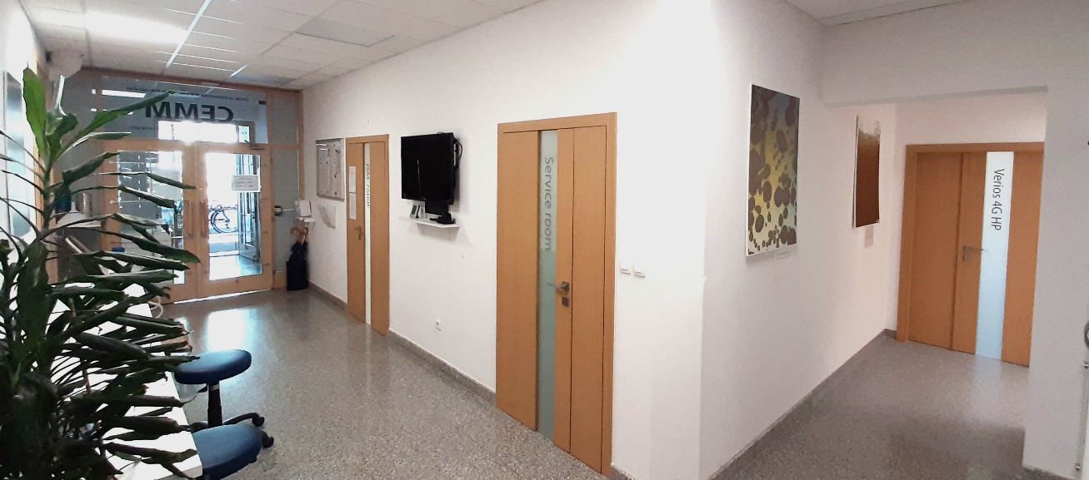

Figure 1. Centre for Electron Microscopy and Microanalysis (CEMM).

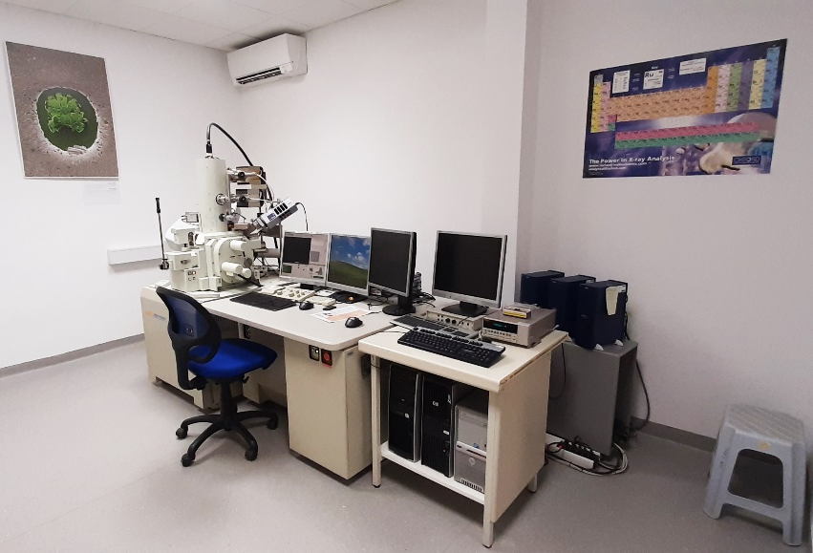

Figure 2. Scanning electron microscope JSM-7600F.

High-resolution scanning electron microscope Verios G4 HP, Thermo Fisher Scientific (Figure 3) is unique in this part of Europe and provides extremely high imaging resolution at low accelerating voltages. It also features automatic sample insertion and the ability to observe non-conductive specimens with exceptional Z-contrast even at low voltages. In addition to the highly sensitive EDXS detector, the microscope is equipped with a transmission detector (STEM) as well.
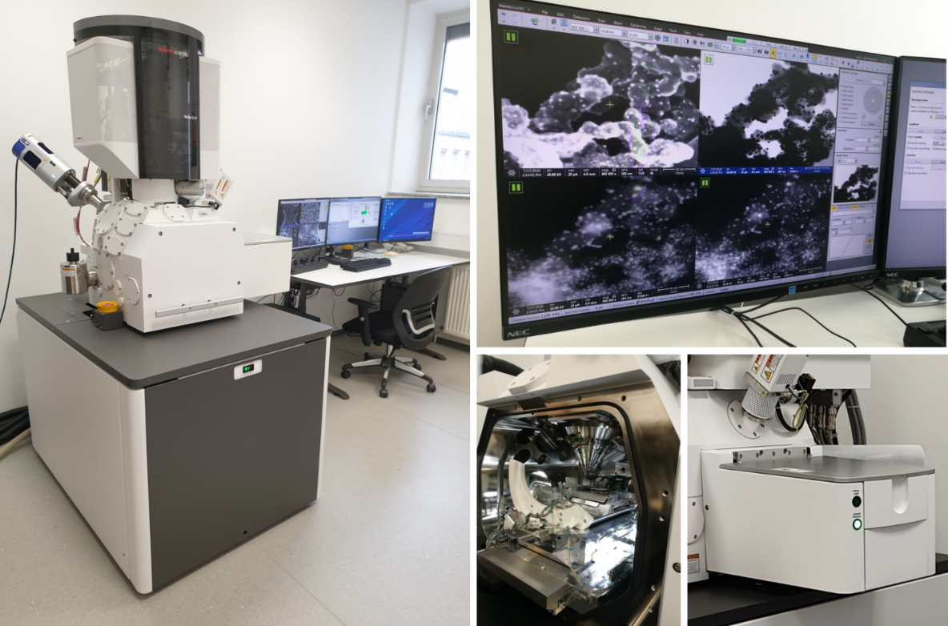

Figure 3. Scanning electron microscope Verios 4G HP.

Scanning electron microscope Quanta 650, Thermo Fisher Scientific (Figure 4) is operational in three vacuum ranges that are achieved through differential pumping. This allows us to investigate a wide range of materials, both conductive and non-conductive.

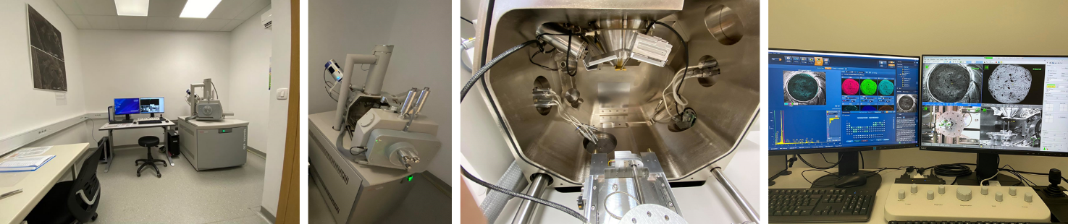

Figure 4. Scanning electron microscope ESEM Quanta 650.

Scanning transmission electron microscope Spectra 300 (Thermo Fisher Scientific) (Figure 5) is the most modern research equipment of the last generation of transmission electron microscopes and enables comprehensive structural and chemical characterization of materials at the atomic and subatomic level. The microscope has an FEG electron source, a spherical aberration corrector and a monochromator and enables the following scanning electron microscopy techniques to be performed: observation with a parallel electron beam (TEM, HRTEM), electron diffraction (SAED, CBED, PED), 4D STEM, qualitative and quantitative chemical analysis (EDXS, EELS), all with the ultimate imaging and analysis resolution at the atomic and subatomic level.

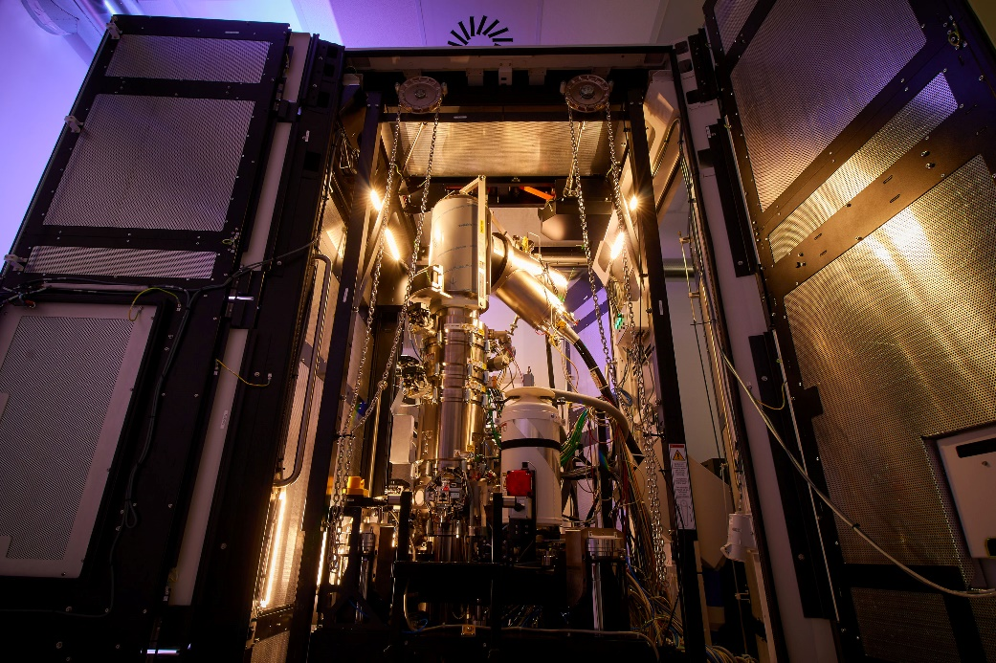

Figure 5. Spectra 300 scanning transmission electron microscope.

The research carried out using the equipment in the CEMM is diverse due to many different research topics of the JSI departments:
- Scanning electron microscopy is employed to observe the morphology and the structure of surfaces and for the microstructural investigation and determination of the chemical composition of investigated materials. Samples that are most frequently investigated are ceramics (polycrystalline oxide and non-oxide compositions), nanostructured materials, metallic magnetic materials, metals, alloys glass, etc. All of the scanning electron microscopes in the CEMM are equipped with an energy-dispersion (EDXS) and/or wavelength-dispersion (WDXS) spectrometer for X-rays, allowing non-destructive determination of the chemical composition of the investigated materials. The scanning electron microscope JSM-7600F is additionally equipped with an electron back-scattered diffraction (EBSD) detector and an electron lithography system. The equipment of the Verios 4G HP microscope enables the observation of the morphology of nanoparticles and samples which are sensitive to electron doses. The Quanta 650 microscope allows the observation of larger, conductive or non-conductive samples.
- Transmission electron microscopy (TEM) provides an insight into the structure of the material on the nano-scale (atom level). Transmission electron microscopy enables structural and chemical analyses of nanostructured phenomena, such as grain boundaries, precipitates, planar defect, dislocations, etc. Materials which are investigated include thin films on different substrates, alloys, metallic magnetic materials, dielectric materials, ferroelectrics, etc. Transmission electron microscope JEM-2100 is equipped with an EDXS spectrometer and a CCD camera, and the JEM-2010F is additionally equipped with a scanning transmission electron (STEM) unit, EDXS and EELS (electron energy loss) spectrometers, and a CCD camera. The ARM200CF is a dedicated scanning transmission electron microscope with ADF, HAADF, ABF STEM detectors and GIF system.
- The CEMM also manages the necessary equipment for the SEM and TEM sample preparation.

The operation of the Centre is managed by the CEMM personnel. Besides maintenance of the equipment, other CEMM activities include, among other, training of new operators, organization of workshops and conferences on the topic of electron microscopy, providing services for industrial partners and implementation of new analytical techniques. CEMM personnel are also responsible for the dissemination of electron microscopy techniques to the general public in the scope of organized visits to the IJS, as well through publications in traditional and digital media.

Examples of microstructural and nanostructural investigations of materials using the CEMM equipment

The examples of analyses of structural and chemical characterisations of different materials using electron microscopy techniques were performed by the operators from different JSI departments and by the CEMM personnel.

- Analysis of 0.5(Ba_{0.8}Ca_{0.2})TiO₃−0.5Ba(Zr_{0.1}Ti_{0.9})O₃ layer on Pt/TiO₂/SiO₂/Si base

STEM image taken with scanning electron microscope Verios G4 HP, from left to right: bright field, dark field mode and HAADF image. Layer of 0.5(Ba_{0.8}Ca_{0.2})TiO₃−0.5Ba(Zr_{0.1}Ti_{0.9})O₃ on Pt/TiO₂/SiO₂/Si base is prepared by solution synthesis. The picture was acquired during training on CEMM equipment (Figure 6).

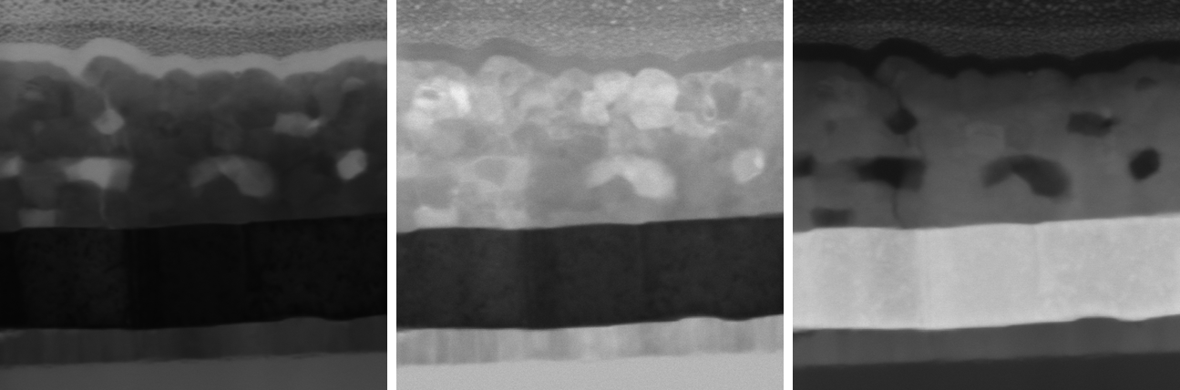

Figure 6. STEM image from left to right: bright field, dark field mode and HAADF image. (Katarina Žiberna, K5, Jitka Hreščak, CEMM, SEM Verios G4 HP).

- Analysis of Pt nanoparticles on carbon nanospheres

Analysis of Pt nanoparticles on carbon nanospheres at magnification 200.000x, taken with scanning electron microscope Verios G4 HP (Figure 7).

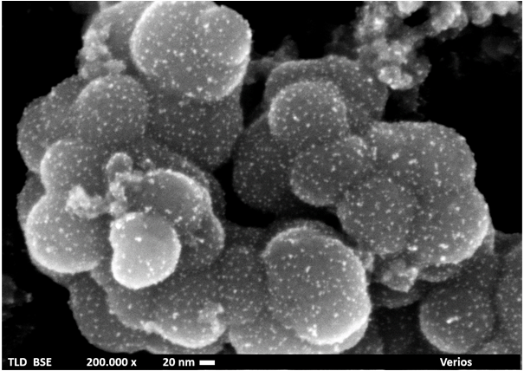

Figure 7. SEM images of Pt nanoparticles (Zoran Samardžija, K7, Kristina Žagar Soderžnik, K7, SEM Verios G4 HP).

- Study of diffusion of crystalline ZrO₂ in porcelain after deformation

EDXS study of ZrO₂ and deposited porcelain layers. The sample was subjected to deformation, i.e. bending under pressure, where the sample has visibly deformed. The study is based on the assumption of diffusion transfer of ZrO₂ into the adjacent porcelain layer or diffusion of porcelain into the ZrO₂ layer. (Figure 8).

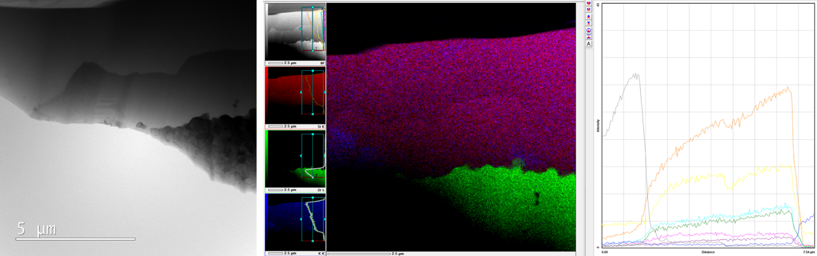

Figure 8. (left) TEM image of ZrO₂ layer and porcelain (left), (middle, right) EDS spectrum over the diffusion layer (Drev S., CEMM, Jeol-ARM200CF)

- Nanocrystalline CeO₂ coating

TEM analysis of nanocrystalline CeO₂ coating on Fe₂O₃ magnetic nanoparticles (Figure 9).

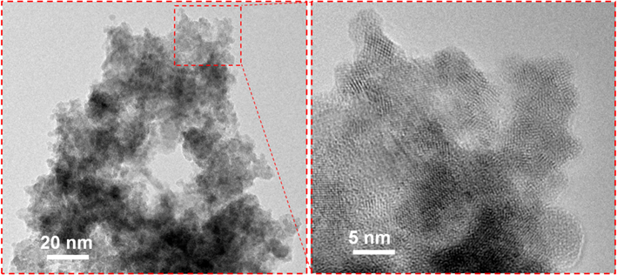

Figure 9. TEM images of nanocrystalline CeO₂ coating (Darko Makovec, K8, JEM-2100).

- A study of H₂Ti₃O₇ nanotubes (TiNTs)

TEM image of H₂Ti₃O₇ nanotubes (TiNTs) that were used in study of delivery of antibiotic Flumequin by titanate nanotubes for use in aquaculture. The inner diameters of nanotubes range from 2 to 6 nm with the average value of 3.2 nm. The outer diameter varies between 6 and 13 nm with the average value of 8.3 nm (Figure 10).

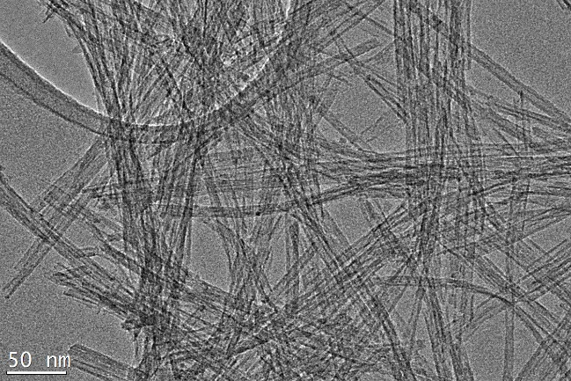

Figure 10. TEM image of H₂Ti₃O₇ nanotubes (TiNTs). (Polona Umek, F5, JEM-2100).

Ref: BAATI, Tarek, BRAHIM, Mounir Ben, SALEK, Abir, SELMI, Mouna, NJIM, Leila, UMEK, Polona, AOUANE, Aicha, HAMMAMI, Mohamed, HOSNI, Karim. Flumequine-loaded titanate nanotubes as antibacterial agents for aquaculture farms. RSC advances, ISSN 2046-2069, 2022, vol. 12, iss. 10, str. 5953-5963, ilustr., doi: 10.1039/d1ra08533f. [COBISS.SI-ID 102359299], [JCR, SNIP, WoS do 27. 3. 2022: št. citatov (TC): 0, čistih citatov (CI): 0, Scopus do 24. 1. 2023: št. citatov (TC): 1, čistih citatov (CI): 1].

EMPLOYEES

- Prof. Miran Čeh, head
- Dr. Sandra Drev
- Dr. Jitka Hreščak
- Andreja Šestan Zavašnik, univ. dipl. inž. kem. inž.
- Aleksander Učakar, mag. inž. metal. in mater.
- Petra Drnovšek, dipl. graf. in med. teh.

